Pokhara University

Level: Bachelor | Semester – Spring | Year : 2006
Programme: BE |  | Full Marks: 100
Course: Digital Signal Processing |  | Time : 3hrs.

Candidates are required to give their answers in their own words as far as practicable.
The figures in the margin indicate full marks.

Attempt all the questions.

 | - What are basic elements of Digital Signal Processing? What are the advantages of digital signal processing over analog signal processing?  - Find out the output of the LTI system when the input is x[n]={1,1,1} and impulse response in h[n]={2,1,2} | 7  8
 | - Determine whether or not the given signal y(n) = n² x(n) is  i) linear ii) causal  iii) stable and iv) shift invariant  - Determine the inverse Z – transform  X(Z) = 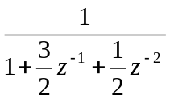  When ROC: 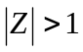 and ROC: 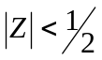. | 8  7
 | - Define DFT. Determine the computational complexity of DFT and compare it with the FFT using any FFT algorithm.  - Compute DFT if x (n) is given as,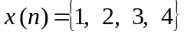. | 10  5
 | - Realize the following system by its direct form I and form II structure.  y[n] = x[n] – 2x[n-1] + 0.5x [n-2] + 0.8y [n-2]  - Determine the lattice coefficients corresponding to the FIR filter with system function and also draw the lattice structure.  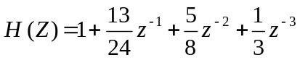. | 8  7
 | - Determine the lowest order of a transfer function H(s) using Butterworth low pass approximation method with following specifications:  Pass Band ripple: 1 dB  Pass Band cut off frequency: 1 KHz  Stop Band ripple: 50 dB  Stop Band cut off frequency: 5 KHz  If the above specifications are to be met by Chebyshev filter, what is the order?  - "Ideal low pass filter cannot be realized in practice". Justify this statement. How do Gibbs phenomena occur in FIR filter design? What can be done to reduce it? | 8  7
 | - What is linear phase FIR filter? Discuss about FIR filter design by frequency sampling method.  - Discuss the IIR filter design by impulse invariance method. | 8  7
 | Write short notes on (Any Two):  - General and special purpose DSP processor  - Limit cycle oscillation  - Quantization error | 2×5

